
A Touch Of Spiritual Class
BY MISHA DAVENPORT STAFF REPORTER  Those heading to Old St. Mary's Church this afternoon are in for a few welcome surprises. The first being Chicago's oldest Catholic parish--founded in 1833--is now offering concerts and recitals in its new home at 1500 S. Michigan.  The second surprise is that they've tapped Robert Sims for the first concert. Sims, a classically trained baritone who holds a masters degree in opera, will be performing a set of African-American spirituals.  What also is surprising is hearing that he once sang opera with R&B-soul superstar R. Kelly. "We both studied with the great Lena McLin," a noted music teacher at the Kenwood Academy in Hyde Park. "She wanted us to be well-rounded, regardless to what we wanted to end up doing," Sims says.  Sims doe not think that it's that big a deal. He quickly recites a list of other people who have studied with McLin, including Mandy Patinkin and a host of singers who populate Broadway stages and the Metropolitan Opera. | 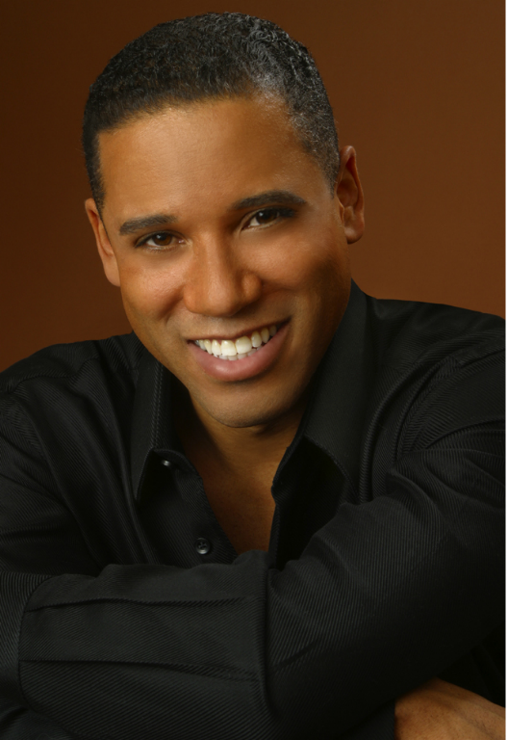
While he and Kelly have chosen different career paths, Sims is still close with McLin, who has arranged many spirituals, including several that he will be performing Sunday.
Even without her training and influence, Sims would still be drawn to spirituals.
"Something about them speaks to me. Their melodies are simple and yet profound. That's why they've lasted all these years and people draw from them all the time.
"Spirituals are the genesis for all great American music. Something about them just touches the soul."
Sims says spirituals have influenced a wide range of American music, from blues and jazz to hip-hop and rap. And despite the fact many songs in the spiritual canon were written in the 16th and 17th centuries, few would consider them "classical music."
"Why not celebrate them in a full recital," Sims says. "These are American classics."
Though Sims tries to stay clear of the 25 or so well known spirituals, he says concert goers might still recognize a melody or two.
"So many spirituals have been adapted into gospel or blues songs, people aren't even aware they were originally spirituals," he says. "Many songs we know come from early African songs.
"There's nothing new under the sun."

